MONGODB

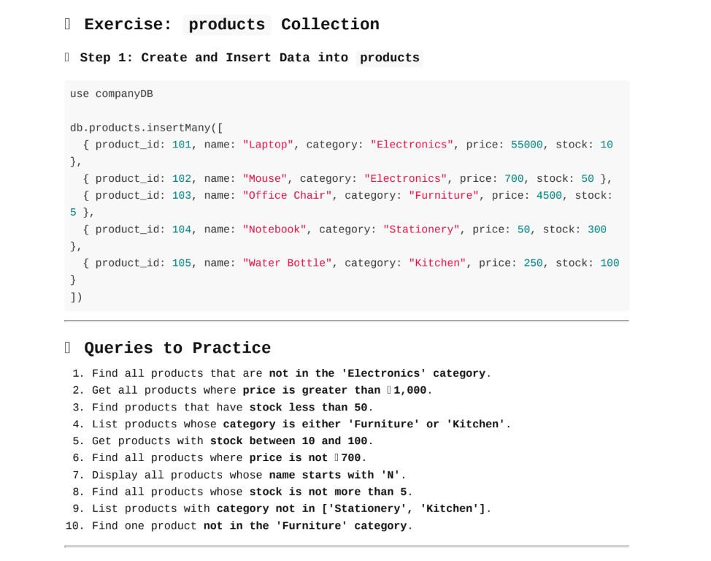

1. Find all products that are not in the 'Electronics' category.

db.products.find({category:{$ne:”Electronics”}})

1. Get all products where price is greater than 1,000.

db.products.find({price:{$gt:1000}})

1. Find products that have stock less than 50.

db.products.find({stock:{$lt:50}})

1. List products whose category is either 'Furniture' or 'Kitchen'.

db.products.find({category:{$in:[“Furniture”,”Kitchen”]}})

1. Get products with stock between 10 and 100.

db.products.find({stock:{$gte:10,$lte:100}})

1. Find all products where price is not 700.

db.products.find({price:{$ne:700}})

1. Display all products whose name starts with 'N'.

db.products.find({name:{regex:”^N}})

1. Find all products whose stock is not more than 5.

db.products.find({stock:{$lte:5}})

1. List products with category not in ['Stationery', 'Kitchen'].

db.products.find({category:($nin:[“Stationery”,”Kitchen”]}})

1. Find one product not in the 'Furniture' category.

db.products.findOne({category:{$ne:”Furniture”}})